**PostgreExercisesAssignment**

First I insert clubdata file:

ScreenShots;

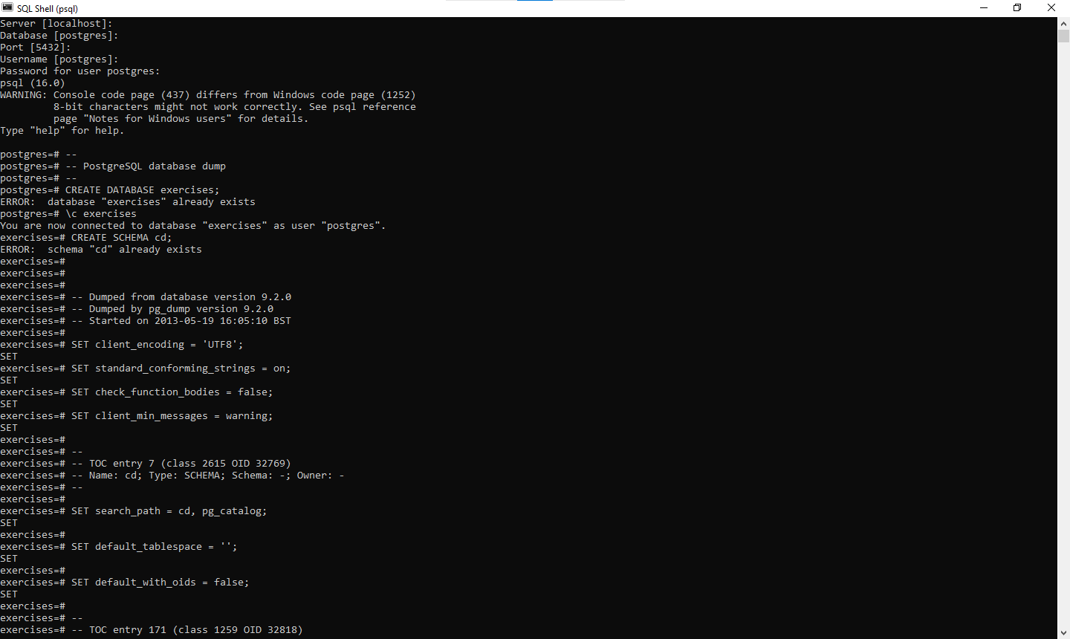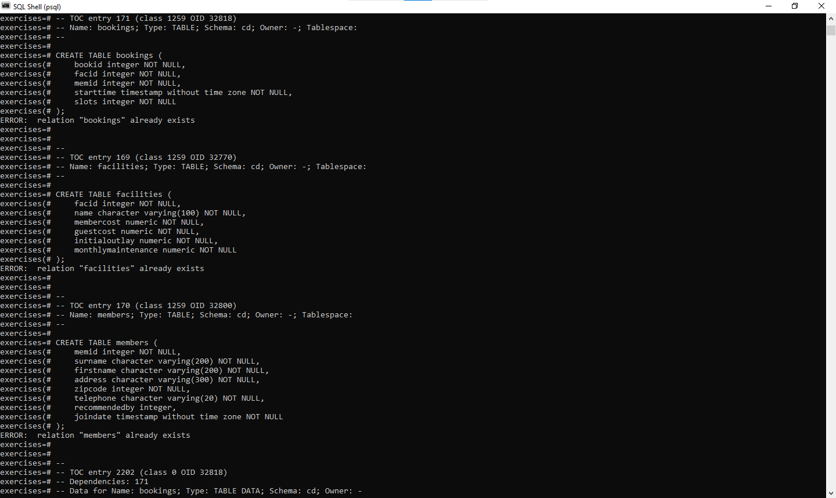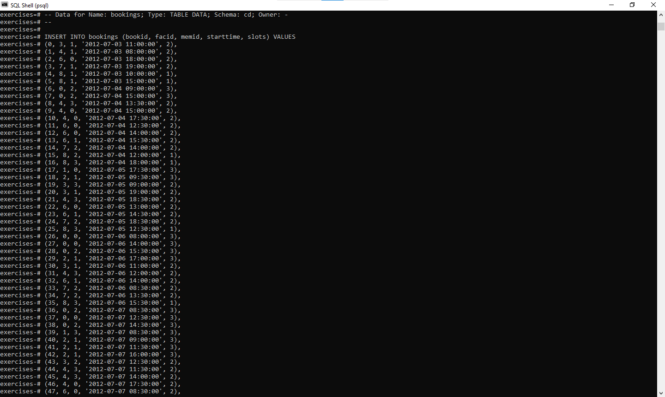

**To Choose Database Exercise:**

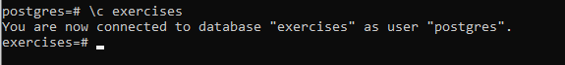

**Simple SQL Queries**

**1.[Retrieve everything from a table](https://pgexercises.com/questions/basic/selectall.html)**

**Query:** Select * from facilities

**SQLOUTPUT:**

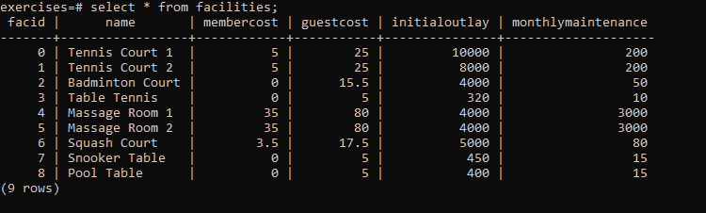

**2.[Retrieve specific columns from a table](https://pgexercises.com/questions/basic/selectspecific.html)**

**Query:** select name, membercost from facilities;

**SQLOUTPUT:** 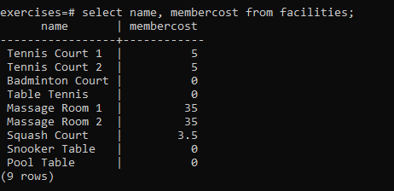

**3.[Control which rows are retrieved](https://pgexercises.com/questions/basic/where.html)**

**Query:** select * from facilities where membercost > 0;

**SQLOUTPUT:**

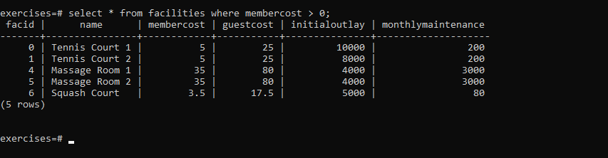

**4.[Control which rows are retrieved - part 2](https://pgexercises.com/questions/basic/where2.html)**

**Query:** select facid, name, membercost, monthlymaintenance from facilities where membercost > 0 and (membercost < monthlymaintenance/50.0);

**SQLOUTPUT:**

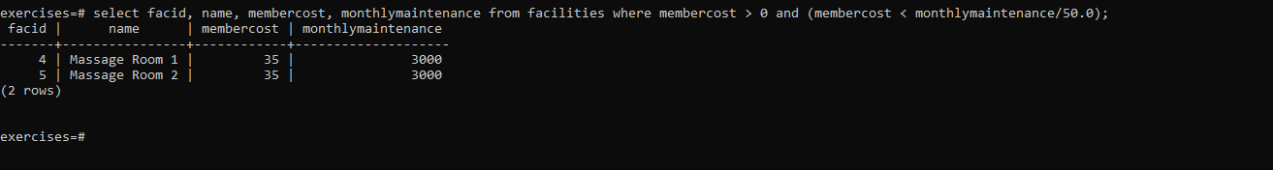

**5.[Basic string searches](https://pgexercises.com/questions/basic/where3.html)**

**Query:** select * from facilities where name like '%Tennis%';

**SQLOUTPUT:**

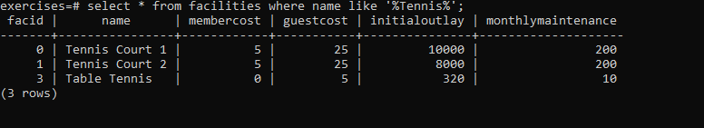

**6.[Matching against multiple possible values](https://pgexercises.com/questions/basic/where4.html)**

**Query:** select * from facilities where facid in (1,5);

**SQLOUTPUT:** 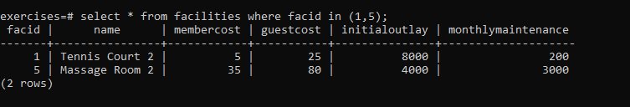

**7.[Classify results into buckets](https://pgexercises.com/questions/basic/classify.html)**

**Query:** select name, case when (monthlymaintenance > 100) then 'expensive' else 'cheap' end as cost from facilities;

**SQLOUTPUT:** 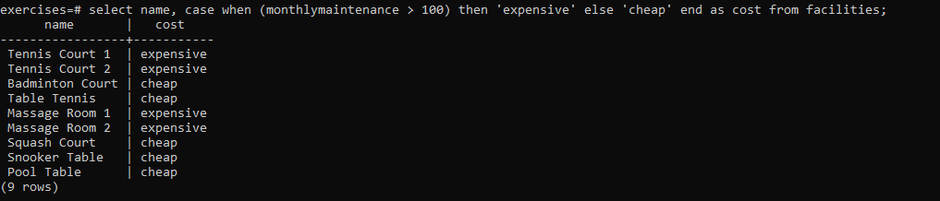

**8.[Working with dates](https://pgexercises.com/questions/basic/date.html)**

**Query:** select memid, surname, firstname, joindate from members where joindate >= '2012-09-01';

**SQLOUTPUT:**

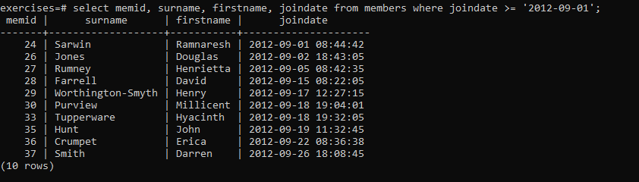

**9.[Removing duplicates, and ordering results](https://pgexercises.com/questions/basic/unique.html)**

**Query:** select distinct surname from members order by surname limit 10;

**SQLOUTPUT:** 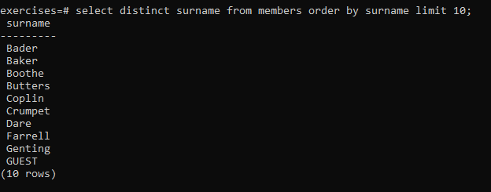

**10.[Combining results from multiple queries](https://pgexercises.com/questions/basic/union.html)**

**Query:** select surname from members union select name from facilities;

**SQLOUTPUT:** 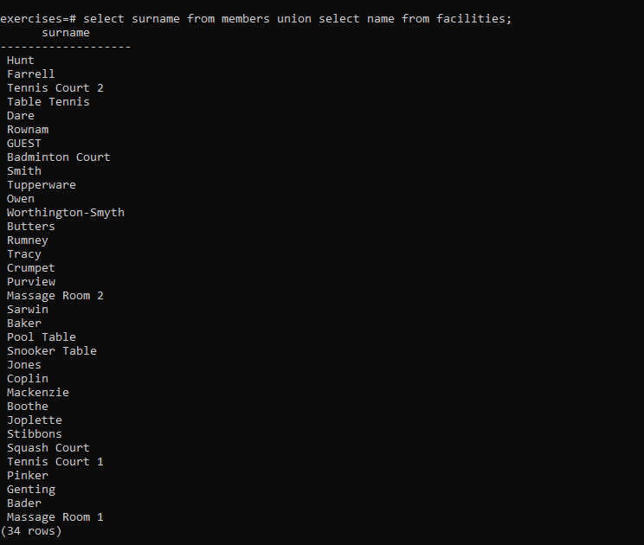

**11.[Simple aggregation](https://pgexercises.com/questions/basic/agg.html)**

**Query:** select max(joindate) as latest from members;

**SQLOUTPUT:** 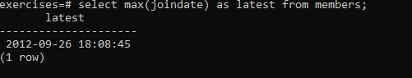

**12.[More aggregation](https://pgexercises.com/questions/basic/agg2.html)**

**Query:** select firstname, surname, joindate from members order by joindate desc limit 1;

**SQLOUTPUT:** 